# *Project Proposal*

# Wat ze öll sould I eat this week. *

*(suppose to sound frensh)

# Description:

Every day there is the same question over and over again, what should we eat. If we zoom out the question is even bigger on a weekly basis, what should we eat this week. This tool will help you in that quest.

The tool is a desktop application that will pull some recipes from the internet and display them in the following format: Description, image, steps. This will be presented in a listview and by clicking on the item some more details will be given.

Once done you will be able to select up to 7 recipes to create the shopping list.

* Ingredient will be grouped on the shoppling list, no duplication.
* Ingredients can also be categorized by area.

# Class-diagram

# Timeline

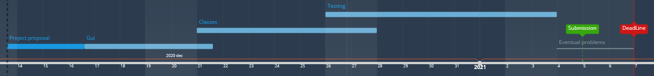

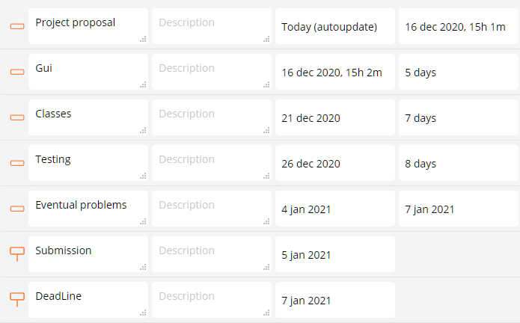

Raw UML data for diagram:

[MainForm

|cookbook: Cookbook

|GetReciepies();

GetRecipe(index);

CompileShoppingList()]

[RecipeForm

|Recipe: Recipe

|DispalyReciepe();

SetIngredientCategory();]

[ShopplingList

|cookBook = Cookbook

|ExportList()]

[Cookbook

|Reciepies: Recipe

|AddRecepie()]

[Ingredient

|Id: int;

Name: string;

Category: string;

Amount: int;

Type: string

|addCategory(user,pass)]

[Recipe

|Name: string;

Ingredients: Ingredient;

Description: string;

Image: string;

SelectedForShoppingList: bool]

// Chain elements like this

[MainForm

]-cookbook*[Cookbook

]-recepies*[Recipe

]-ingredients*[Ingredient

]

// Chain elements like this

[MainForm

]-[RecipeForm

]-[Cookbook

]

[MainForm

]-[ShopplingList

]-[Cookbook

]